**Family Connection from Naviance**

***Registration Information***

***\*\*\*Please see a member of the counseling staff for registration codes\*\*\****

http://connection.naviance.com/hisd-carnegie

Separate codes issued for student & each parent/guardian. Please ensure that all parties register using a valid email address to effectively communicate with the counseling and guidance office at CVHS.

**Carnegie Vanguard High School** is pleased to introduce Family Connection from Naviance, a web-based service designed especially for students and parents. Family Connection is a comprehensive web site that you can use to help in making decisions about colleges and careers. Family Connection is a service that we use in the Guidance Office to track and analyze data about our student’s college and career plans. Family Connection will allow you to:

* Get involved in the planning and advising process - Build a resume, complete on-line surveys, and manage timelines and deadlines for making decisions about colleges and careers.
* Research colleges - Compare GPA, standardized test scores, and other statistics to actual historical data from students who have already applied from our high school.
* Sign up for college visits - Find out which colleges are visiting our school and sign up to attend those sessions.
* Receive valuable information from your counselors regarding course schedules, to-do lists, email correspondence, etc.

**Activate Your Account**

Use the personalized registration code to log onto http://connection.naviance.com/hisd-carnegie. Set up your Naviance account as a new user. You will need to create a password and provide an email address. If you have already registered, you can skip this step. For returning users, the email address and password you provided during registration will be your way to sign into your account.

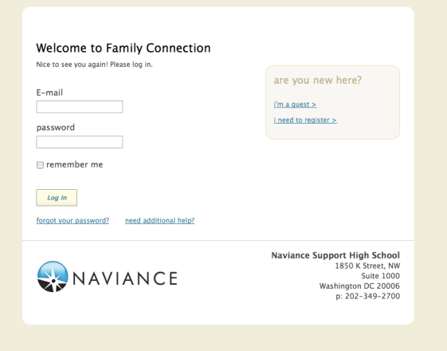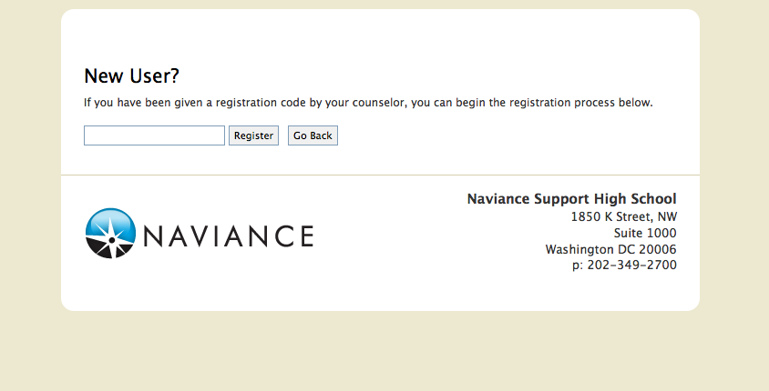

**Selected Software Features to Explore**

|  |  |  |
| --- | --- | --- |
| ***Feature*** | ***Description*** | ***How to Access*** |
| *Résumé* | * Record your high school activities, awards, volunteer experience, etc. * Rearrange your information into multiple printable versions of a résumé that you can use to present to potential employers or colleges. | 1. Click the *About Me* tab 2. Click the *Résumé* hyperlink under the *Interesting Things About Me* section |
| *Explore Interests* | * Take a career survey, a tool that can help you discover the types of work activities and careers that match your interests. Use the results to explore suggested occupations; examine the education, training, and skills required [and where to obtain them], as well as wages typical for these occupations. | 1. Click the *Careers* tab 2. Click the *Career Interest Inventory* hyperlink under the *What Are My Interests?* section |
| *Do What You Are* | * A personality survey. Use the results to explore suggested college majors and careers based on your preferences and strengths. | 1. Click the *About Me* tab 2. Click the *Personality Type* hyperlink under the *Interesting Things About Me* section |
| *College Search* | * Set search criteria to yield a list of colleges to explore. Save your search to access/modify later. * Click on the various tabs of the college profile (*general, admissions, financial aid, majors and degrees*, and *student life*) for additional information. * Add colleges you’re interested in to your *My Colleges* list for future reference. You will be notified by email when those colleges schedule a visit our school. | 1. Click the *Colleges* tab 2. Click the *College Search* hyperlink under the *College Research* section |
| *Document Library* | * School specific information; e.g. school profile, transcript request form, recommendation form, master schedule | 1. Click the *From My School* tab 2. Click the *Document Library* |

**College Application Statistics**

College application statistics for the class of 2011 & 2012 are available in Naviance.  To protect student privacy, if fewer than 3 students applied to a college and were accepted, the statistics are not available.

|  |  |  |
| --- | --- | --- |
| ***Feature*** | ***Description*** | ***How to Access*** |
| *Application*  *History* | Summary of CVHS application results (admit, deny, enroll), by year. | 1. Click the *Colleges* tab 2. Click the *College Lookup* hyperlink under the *College Research* section 3. After looking up and selecting a college, the *Application History* table appears in the middle of the page. |
| *School*  *Statistics* | * Historical summary of our school’s application outcomes (number admitted, denied, etc.) by application decision plan (i.e. regular and early decision) by college. * Historical average of GPA, SAT and ACT scores for admitted applicants, by college. | 1. Click the *Colleges* tab 2. Click the *College Lookup* hyperlink under the *College Research* section 3. After looking up and selecting a college, click on *School Stats* hyperlink located beneath the college’s contact information. Two tables are displayed:  * *Outcomes* * *GPA and Test Scores* |
| *Graph* | Historical application results (admit, deny, waitlist) represented in a scattergram (i.e. graph); applicant average GPA appears on the y-axis and applicant average SAT scores on the x-axis. For an applicant to be represented on a scattergram for a given college, three things must be present:  1. an application result (accepted or denied)  2. a GPA  3. a test score | 1. Click the *Colleges* tab 2. Click the *College Lookup* hyperlink under the *College Research* section 3. After looking up and selecting a college, click on *Graph* hyperlink located beneath the college’s contact information. |
| *College*  *Compare* | Compare your GPA and test scores to the average GPA and test scores of our school’s admitted students for colleges you are considering. School averages are displayed in green when your numbers are higher and in red when your numbers are lower than those of past admitted students. | 1. Click the *Colleges* tab. 2. Click the *Colleges I’m Thinking About* hyperlink from the *My Colleges* section. 3. Click the *Compare Me* hyperlink above the table. |